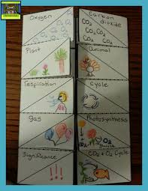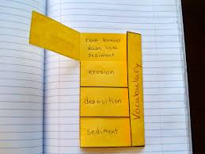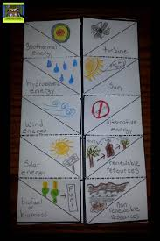
When you open each a flap, you see the definitions. Pictures go on the back of the words. When you open each a flap, you see the definitions.

