Lesson 1
____ ____ 1. Know which cells form haploid cells, and which cells form diploid cells | Sex cells (sperm and egg) form haploid cells. Every other cell are diploid
2. after fertilization, a zygote goes through Mitosis in order to form an embryo, and then a baby. Why not through Meiosis? | Meiosis ends up with half the normal number of chromosomes.
3. we inherit how many copies of each chromosome from each parent? | We inherit one set from out mother, the other set from out father
4. Know the phases of meiosis and what happens in each stage
Prophase I: Nucleus breaks down and DNA forms chromosomes
Metaphase I: Homologous Chromosomes bunch up at the center of cell with spindle fibers attaching to centromeres
Anaphase I: Homologous chromosomes are pulled away from each other
Telophase I: cell splits into two, with nuclear membrane re-forming
Prophase II: Nucleus breaks down and DNA forms chromosomes
Metaphase II: Chromosomes line up at center of cell with spindle fibers attaching to centromeres
Anaphase II: Chromatids are pulled apart to opposite ends of cell
Telophase II: Cells split in two, forming four cells with half the normal DNA
5. Meiosis starts with one diploid cell and ends up with _____ haploid cells | Four
6. What are the advantages of meiosis in sexual reproduction? | A lot of genetic variation
7. a cell that has two copies of every kind of chromosome is ________ | Diploid
8. Remember and understand the following figure:  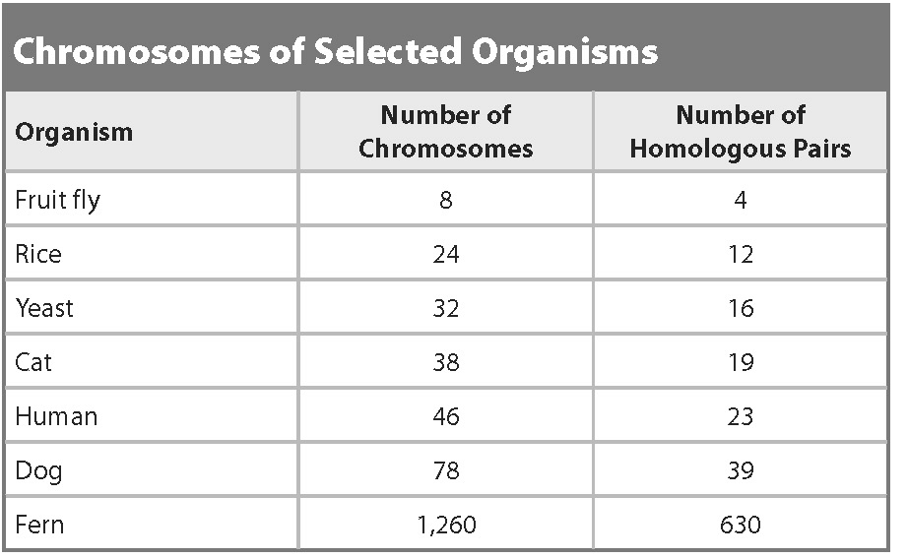 | Homologous pairs means two copies of each chromosome (one from mom, the other from dad)  Eg: fruit flies have 8 chromosomes total, 4 came from its mom, 4 came its dad.
9. How do you find the number of homologous pairs when you only have the total number of chromosomes? | Divide the total number by two
10. What plants, through selective breeding, are descended from a wild mustard plant? How does meiosis help in selective breeding | Kale, Kohlrabi, Cabbage, Broccoli.  Selective breeding allowed for a lot more variation to show up.
Lesson 2
11. Know what happens in binary fission. In what organisms does this occur? | This occurs in prokaryotes (bacteria) DNA is copied, then pulled to opposite ends of the cell, which then grows bigger. Finally, the cell splits in two
12. What happens in vegetative reproduction? In what organisms does this occur? | This occurs in plants. You take a cutting (either a stem or a root) and plant it. This cutting will eventually grow into a full plant.
13. What is budding? How does this occur? | a new organism develops from an outgrowth or bud due to cell division at one particular site.  Occurs in yeast and hydra
14. Know the phases of mitotic cell division and what happens in each stage. | PMAT.
15. Give two examples of organisms that reproduce through regeneration | Planarian flatworms  Hydra  Starfish
16. What two forms of asexual reproduction that occurs in a lab? | Tissue Culture and Cloning
17. What is an advantage of asexual reproduction? | A lot of offspring  There is no need to waste energy and resources making sperm and eggs
18. What is a disadvantage of asexual reproduction? | Higher risk of mutation  No genetic variation

