Lesson 1
____ ____ 1. Know which cells form haploid cells, and which cells form diploid cells

2. after fertilization, a zygote goes through Mitosis in order to form an embryo, and then a baby. Why not through Meiosis?
3. we inherit how many copies of each chromosome from each parent?

4. Know the phases of meiosis and what happens in each stage
5. Meiosis starts with one diploid cell and ends up with _____ haploid cells

6. What are the advantages of meiosis in sexual reproduction?

7. a cell that has two copies of every kind of chromosome is ________

8. Remember and understand the following figure:
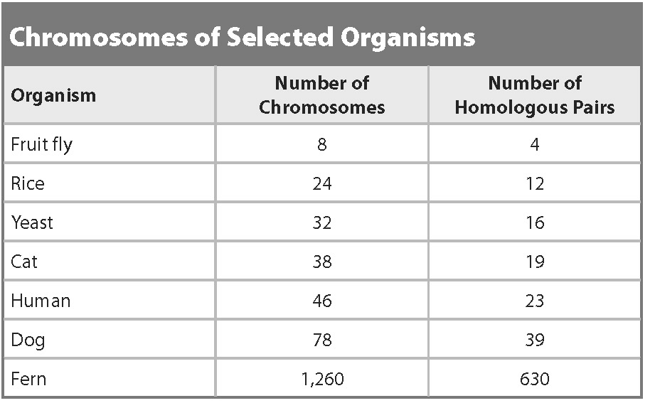
9. How do you find the number of homologous pairs when you only have the total number of chromosomes?
10. What plants, through selective breeding, are descended from a wild mustard plant? How does meiosis help in selective breeding
Lesson 2
11. Know what happens in binary fission. In what organisms does this occur?
12. What happens in vegetative reproduction? In what organisms does this occur?
13. What is budding? How does this occur?
14. Know the phases of mitotic cell division and what happens in each stage.
15. Give two examples of organisms that reproduce through regeneration
16. What two forms of asexual reproduction that occurs in a lab?
17. What is an advantage of asexual reproduction?
18. What is a disadvantage of asexual reproduction?

