Lesson 1
1. What are the three principles of the cell theory?
1.
2.
3.
2. What scientist belongs in the empty box?
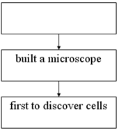
3. What is the name of the scientist who:
a. looked at animal cells
b. looked at plant cells
4. Where are nucleic acids found?
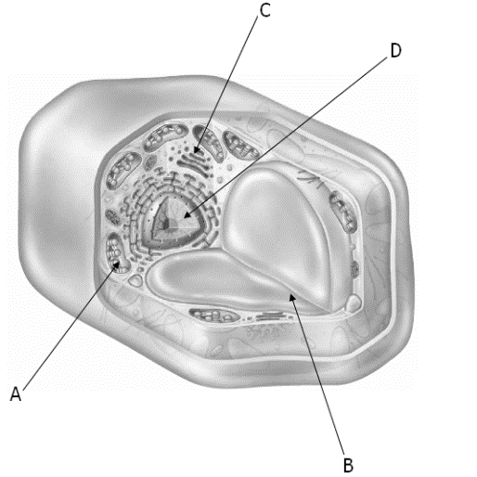
5. _____________ make up the macromolecule carbohydrate.
Lesson 2
6. Explain the function of the cell membrane.

7. Which organelle is necessary for photosynthesis to occur?
8. Describe the main difference between a prokaryotic cell and a eukaryotic cell.

9. What is the difference between the rough endoplasmic reticulum and smooth endoplasmic reticulum?

10. Plant cells that are long and hollow will transport _____ and water throughout the plant.
Lesson 3
11. Describe:
Passive transport-
Active transport-
12. Materials enter and leave the cell through openings in its _______
_____________.
13. Describe osmosis.

14. What is being shown in each diagram:
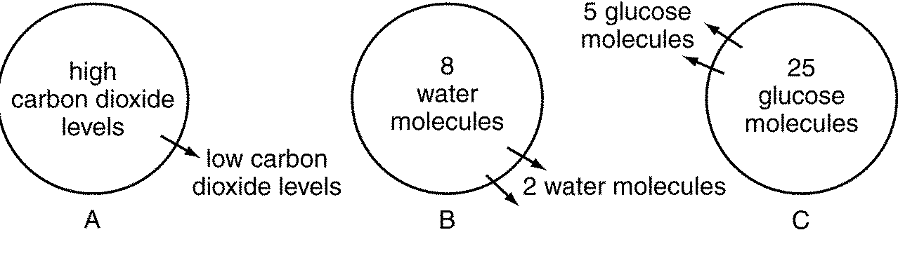
active transport, diffusion, osmosis, equilibrium, exocytosis

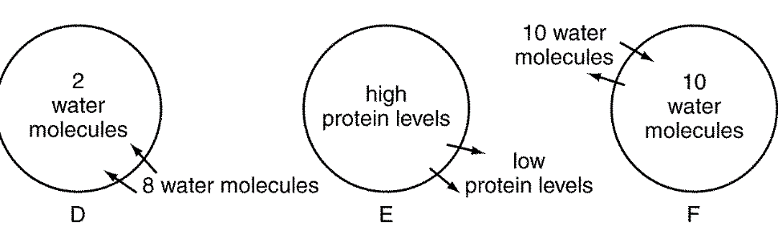
Lesson 4
15. What substance is released during photosynthesis?

16. Which form of energy is necessary in photosynthesis?

17. What process is being shown below:
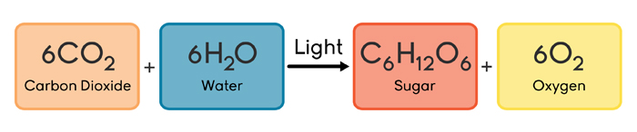
Matching
A. cell membrane C. cytoplasm E. golgi bodies G. nucleus
B. vacuoles D. cell wall F. mitochondria H. organelles

____ 1. Organelles that store food, water, and waste material
____ 2. Protective layer around all cells
____ 3. Where the energy in food is stored until it is released
____ 4. Protects the cells of plants
____ 5. Flattened membranes that package proteins
____ 6. Gelatinlike material inside cell membrane
____ 7. Structures within the cytoplasm of eukaryotic cells
____ 8. Directs all the activities of the cell

