Name: __________________________________ Date: ________________ Period: ______

8th Grade Nature of Science (NOS) Test Study Guide – Please note that the format of this test is based on how students will be assessed on the science FCAT 2.0. Therefore, many of the problems/questions are scenario based.

Topics to Know:

1. How do you improve a scientific investigation?

2. How do you make a conclusion based on scientific data?

3. Understand the difference between a well-designed and flawed experiment.

4. How can you identify when experimental results support or reject a hypothesis?

5. Understand how to read and analyze data from data tables, charts, and graphs.

6. The value of having a testable hypothesis.

7. Why are experiments repeated and replicated several times before a final conclusion is made?

8. What does it mean to have repeated experimental trials?

9. How do scientists determine what to test and how to test it in an experiment?

10. When are experimental results validated?

11. Difference between scientific theories and laws and societal laws.

12. Know how to identify metric prefixes and base units. Know how to convert between SI units using the following table:
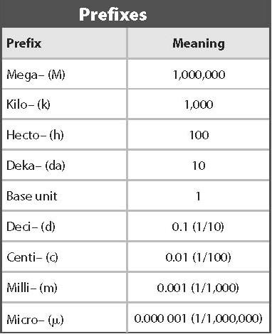

13. Understand what the units of this table represent and what each unit means/measures.

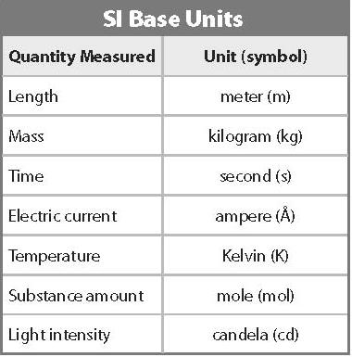

14. What is science?

15. Why is technology important?

16. What are two ways that scientists communicate their results to other people?
Name: __________________________________ Date: ________________ Period: ______

KEY, 8th Grade Nature of Science (NOS) Test Study Guide – Please note that the format of this test is based on how students will be assessed on the science FCAT 2.0. Therefore, many of the problems/questions are scenario based.

Topics to Know:

1. How do you improve a scientific investigation?
By going back and checking over your experiment to ensure that you explored as many possibilities and tested what you wanted to test.

2. How do you make a conclusion based on scientific data?
Conclusions are made once data is analyzed. Your results either support your hypothesis or cause it to be rejected.

3. Understand the difference between a well-designed and flawed experiment.
Well-designed experiments test what the experimenter wants to test. Flawed experiments typically did not take something important into account.

4. How can you identify when experimental results support or reject a hypothesis?
Your hypothesis is supported when your results agree with what you predicted at the beginning. Hypotheses are rejected when the results and data do not agree with your “educated guess”.

5. Understand how to read and analyze data from data tables, charts, and graphs.

6. The value of having a testable hypothesis.
A hypothesis is testable when you can actually carry out an experiment on it.

7. Why are experiments repeated and replicated several times before a final conclusion is made?
This helps to ensure that the results obtained were not accidental and that if another scientists repeats the experiment, the will get very similar and reliable results.

8. What does it mean to have repeated experimental trials?
This means to do the experiment several times.

9. How do scientists determine what to test and how to test it in an experiment?
This is based on their hypothesis. In other words, what are they testing and why are they testing it.

10. When are experimental results validated?
Results are validated when they can be reproduced several times and by other scientists.

11. Difference between scientific theories and laws and societal laws.
Scientific theories are accepted as fact but remain changeable if new data/evidence becomes available. Scientific laws are facts that never change and describe one thing in nature. Societal laws are laws that people in a community decide upon and enforce.

12. Know how to identify metric prefixes and base units. Know how to convert between SI units using the following table:

13. Understand what the units of this table represent and what each unit means/measures.

14. What is science?
Science is the study of the natural, physical, chemical, and living world.

15. Why is technology important? Technology helps us to measure more accurately and consistently.

16. What are two ways that scientists communicate their results to other people?
They communicate by writing reports and doing presentations.

