Name: __________________________________ Date: ________________ Period: ______

8th Grade Nature of Science (NOS) Test Study Guide – Please note that the format of this test is based on how students will be assessed on the science FCAT 2.0. Therefore, many of the problems/questions are scenario based.

Topics to Know:

1. How do you improve a scientific investigation?

2. How do you make a conclusion based on scientific data?

3. Understand the difference between a well-designed and flawed experiment.

4. How can you identify when experimental results support or reject a hypothesis?

5. Understand how to read and analyze data from data tables, charts, and graphs.

6. The value of having a testable hypothesis.

7. Why are experiments repeated and replicated several times before a final conclusion is made?

8. What does it mean to have repeated experimental trials?

9. How do scientists determine what to test and how to test it in an experiment?

10. When are experimental results validated?

11. Difference between scientific theories and laws and societal laws.

12. Know how to identify metric prefixes and base units. Know how to convert between SI units using the following table:
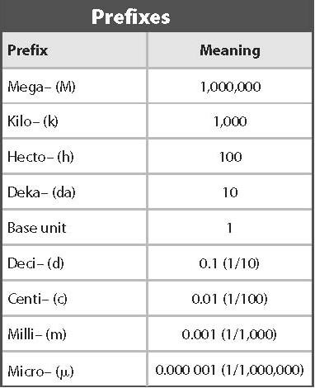

13. Understand what the units of this table represent and what each unit means/measures.

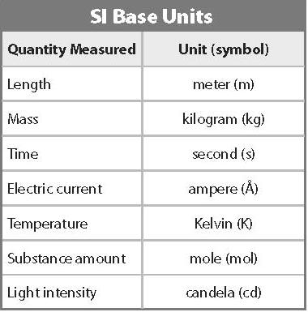

14. What is science?

15. Why is technology important?

16. What are two ways that scientists communicate their results to other people?

