Name: _______________________________ Date: _______________ Period: ______
8th grade - Chapter 3 Study guide: Stars and Galaxies

1. Terms to know: apparent and absolute magnitude, astronomical unit (AU), luminosity, light-year, planetary nebulae, parallax, sunspots, solar flares, solar winds, coronas, black holes, prominences, and Milky Way galaxy (what is it and where are we located).

2. Study this diagram and be able to label the layers of a star (photosphere, convection zone, radiative zone, and chromosphere).
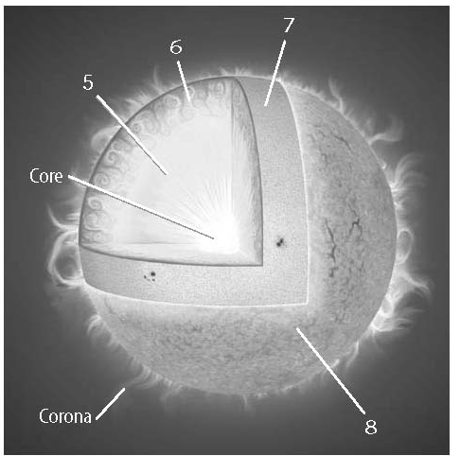
A – radiative zone
B – convection zone
C – photosphere
D – chromosphere

D
C
B
A

3. Difference between constellations and galaxies.
Constellations are patterns of stars in the sky. Galaxies are groups of stars, gas, and dust held together by gravity.

4. Differences between an elliptical, irregular and spiral galaxies.
1. Spiral (middle aged stars pinwheel shaped), 2. Elliptical (older stars with little to no gas or dust) and 3. Irregular (youngest stars with no set shape).

5. The Doppler shift (also consider red and blue shift). What is it? What does it tell us?
The Doppler shift is the change in frequency of a wave for an observer moving relative to its source. In blue shift, objects in space move closer to Earth (decrease in the wavelengths). Red shift is when an object is moving farther away from Earth (increase in wavelength).

6. How is the temperature of a star related to its color?
Blue stars are hot and red stars are cold.

7. What does a star’s luminosity describe?
It describes how bright a star appears from a reference point in space.
8. Where do stars form?
Stars form in a cloud of gas and dust known as a nebula.

9. Describe what the Big Bang theory states.
The Big Bang theory states that between 15 and 20 billion years ago, the universe began expanding out of an enormous explosion.
10. What are the stages in the life cycle of a massive star (hint: there are four)?
1. nebula, 2. protostar, 3.supernova, 4. neutron star
First there is a cloud of dust and gas called a nebula. Then a protostar forms. Later on, the star explodes in a supernova, after which it may form a neutron star.

