Science 3 Ch. 12: Matter and Energy in the Environment Study Guide

Modified True/False - Indicate whether the statement is true or false. If false, change the identified word or phrase to make the statement true.

____ 1. Humans are an ecosystem. _______________

____ 2. The source of almost all energy on Earth is the climate. _______________

____ 3. Soil is made up of rocks and sand. _______________

____ 4. Elements such as oxygen, nitrogen, and carbon cycle through a system once. _______________

____ 5. Carbon is an essential part of proteins and is part of DNA. _______________

____ 6. The amount of oxygen in Earth’s atmosphere has been a constant for millions of years. _______________

____ 7. Energy, just like water, cycles through ecosystems. _______________

____ 8. Chemosynthesis and photosynthesis are both processes to produce food. _______________

____ 9. Consumers produce their own food. _______________

____ 10. Energy cycles through ecosystems because it returns to the Sun. _______________

____ 11. Available energy increases as it is transferred from one organism to another in a food chain. _______________

____ 12. The steps of a food web are called trophic levels. _______________

____ 13. The atmosphere is composed mostly of carbon dioxide. _______________

____ 14. Nitrogen, as it is found in the atmosphere, can be used by plants and animals. _______________

____ 15. Production of food from chemicals is called photosynthesis. _______________

Multiple Choice - Identify the choice that best completes the statement or answers the question.

____ 1. Which of the following is a biotic factor?
a. | Fish | c. | lake
b. | Pond | d. | ocean

____ 2. Which of the following is an abiotic factor?
a. | amoeba | c. | shell
b. | lichen | d. | mold
____ 3. Which of the following is NOT a part of climate?
a. | temperature | c. | soil
b. | moisture | d. | wind

____ 4. The atmosphere protects living things from harmful rays that come from _____.
a. | water | c. | the Sun
b. | Heat | d. | soil

____ 5. Which of the following is NOT part of the water cycle?
a. | nitrogen fixation | c. | condensation
b. | evaporation | d. | precipitation

____ 6. Which of the following would eat a dead rabbit?
a. | carnivore | c. | herbivore
b. | detritivore | d. | omnivore

____ 7. Chemosynthesis may use all of the following except _____ to make food.
a. | carbon dioxide | c. | light energy
b. | chemical energy | d. | water

____ 8. Which of the following steps is second in this food chain?
a. | The snake obtains energy by eating the mouse.
b. | Plants make energy-rich food using sunlight.
c. | The Sun emits energy.
d. | The hawk obtains energy by eating the snake.

Use the figure to answer the following questions.

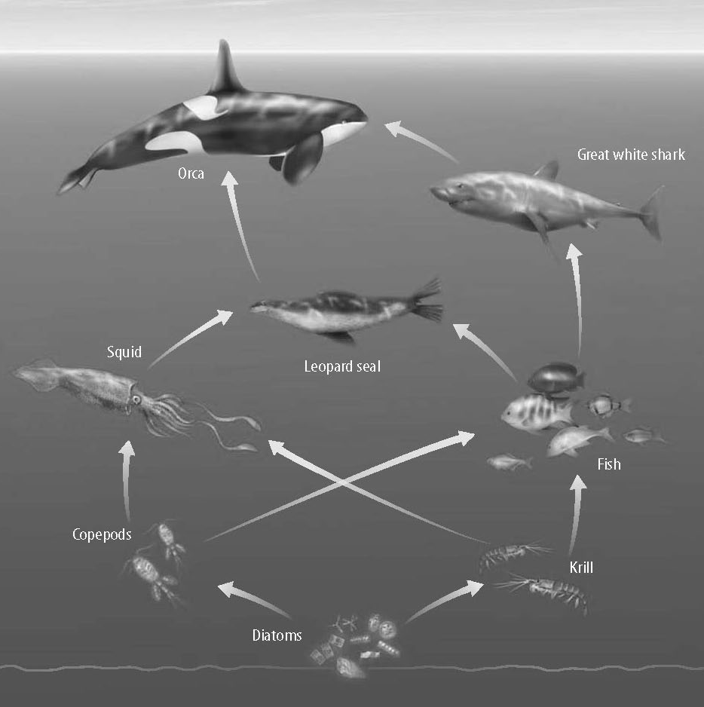
____ 9. In the food web, what eats the squid?
a. | diatoms | c. | leopard seal
b. | squid | d. | orca

____ 10. Which is a model of feeding relationships?
a. | protein building | c. | food web
b. | food map | d. | sugar molecules

Completion - Complete each statement.
1. A rotting log can be an example of a(n) _______________.

2. When you breathe, you are interacting with a(n) __________ factor that is necessary for life.

3. The water level goes down in a glass left on the counter because of ___________.

4. Archaeologists can use __________ for some of their work because it is in every organism.

5. ____________________ are not capable of photosynthesis.

6. Nitrogen fixation is performed by ____________________.

7. The bottom layer of an energy pyramid represents ____________________, the first feeding level.

8. In a food chain, the lowest level of consumers eat ____________________.

9. Overlapping food chains make a food ____________________.

Matching - Match whether each process puts carbon compounds into the atmosphere or into the water or soil.
a. | atmosphere | b. | water or soil
____ 1. Photosynthesis ____ 4. burning coal
____ 2. Combustion ____ 5. seashells break down into sand
____ 3. formation of fossils

Short Answer
1. Name three of the nonliving parts of an ecosystem.
2. Explain the process in the figure.
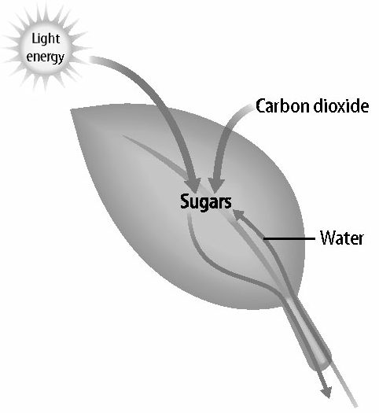
3. What are the three common systems used for modeling ecosystems?
4. If the first trophic level in an energy pyramid receives 1,000 units of energy from the Sun, how much energy is available for the third trophic level?
5. Draw a basic diagram of the water cycle

