Name: __________________________________ Date: ___________________ Per: _______
Study Guide - 8th grade Chapter 10 Test (Chemical Reactions and Equations)

1. Terms to know (study all of the vocabulary words for Chapter 10, especially the following ones):
Physical change | Conservation of mass | Chemical change | Exothermic
Product | Catalyst | Activation energy | Subscript
Endothermic | Inhibitor | Reactant | Rate of reaction
enzyme

**Know how to identify each one given a scenario (ie. wood burning is an example of a chemical rxn).**

2. What type of chemical reaction does each diagram represent?

I ____________________________________________

II ____________________________________________

III 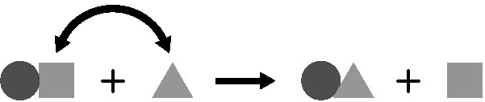 ____________________________________________

IV 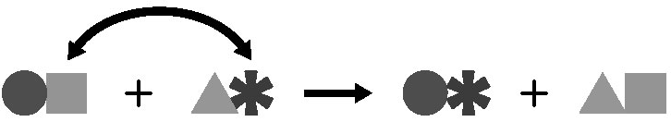 ____________________________________________

3. According to the law of conservation of mass, how do the masses of reactants and products compare in a chemical reaction? __________________________________________________________________________
______________________________________________________________________________________________________________________________________________________________________________________________________________________________________________________________________________

4. In a chemical reaction, r___ a ___ ___ a n ____ ____ (on the left) → ____ r __ d u ____ ___ s (on the right).

5. What happens when a chemical bond is broken?

6. What happens when a chemical bond forms?

7. Which one of the following factors would speed up a chemical reaction? _________________ Which one would slow it down? ____________________________
a. | adding a catalyst
b. | raising the temperature
c. | making the reactant particles larger
d. | increasing the concentration of a reactant

8. If the arrangement of atoms in a substance changes, then what is true? _______________________________
__________________________________________________________________________________________
__________________________________________________________________________________________

9. Study this diagram. Be sure that you area able to draw conclusions based on it.
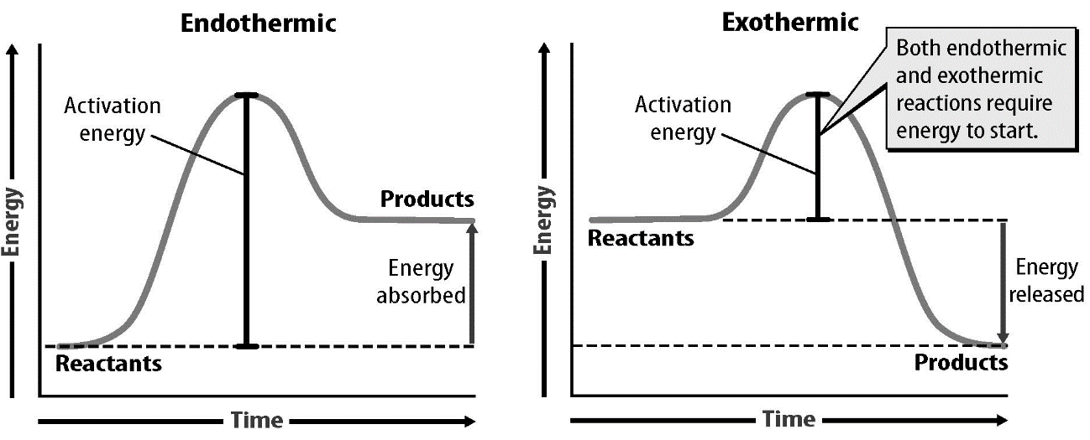

10. Chemical reactions ______.
a. | release more energy than they absorb
b. | absorb more energy than they release
c. | release and absorb exactly the same amount of energy
d. | can either release more energy than they absorb or absorb more energy than they release, depending on the reaction.

11. What are some pieces of evidence that support the observation that a chemical reaction has occurred?
a. | change of color
b. | Precipitate formation
c. | change of chemical properties
d | bubbles
e. | all of the above

