Name: __________________________________ Date: _______________ Period: _____

**Chapter 4 Study Guide: Exploring Space**

1. Terms to Know:

* Space shuttle
* Rocket
* Space probe
* Lunar
* Satellite

2. Study the following diagrams:

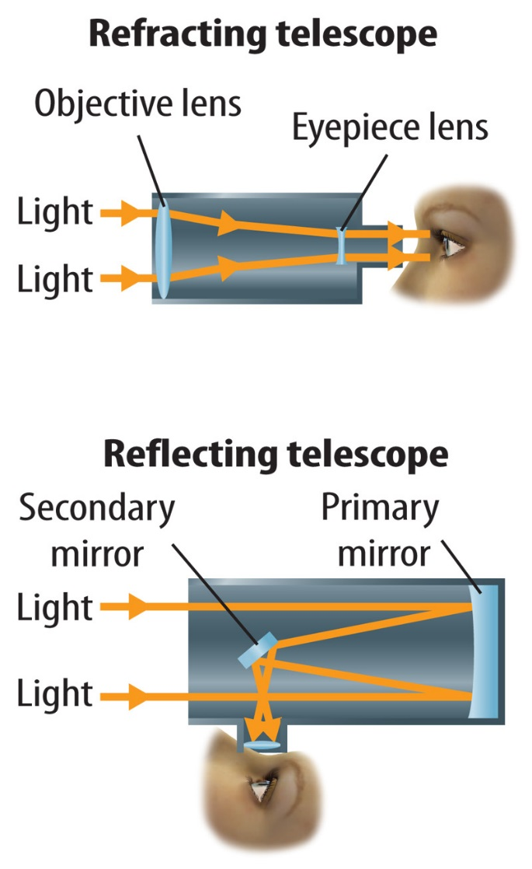 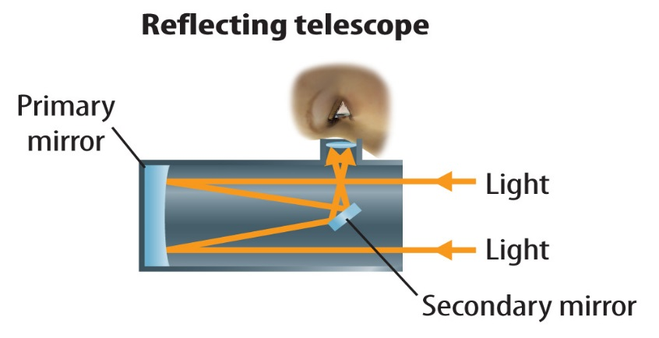

3. What was the first planet studied using a space probe? VENUS

4. Which of the following show signs of the possibility of water? Mars, Europa (one of Jupiter’s moons), Jupiter, or Mars and Europa? MARS AND EUROPA

5. The three things required for life to exist as far as we know are WATER, ENERGY (sunlight), and ORGANIC MOLECULES (we discussed these as a Do Now in class).

6. A star’s TEMPERATURE is determined by studying the amount of each wavelength it emits.

7. Differentiate between a crewed space shuttle, space probe, rocket and crewed spacecraft. In other words, when is each one used?

CREWED SPACE SHUTTLE – USED TO TRANSPORT PEOPLE AND MATERIALS

SPACE PROBE – UNMMANNED SENT FROM EARTH TO EXPLORE SPACE OBJECTS.

ROCKET – VEHICLE MADE TO PROPEL ITSELF BY EJECTING GAS FROM ONE END

CREWED SPACECRAFT – also known as a shuttle

8. Which of the following helps to power missions to the outer planets: wind, gravity from planets as they are passed, solar power, or anti-matter? ________________________________

9. In what year was the moon last visited? 1972

10. What is the role of the *Lunar Reconnaissance Orbiter?* IT LOOKS FOR THE BEST LOCATION FOR A FUTURE LUNAR OUTPOST.

11. Differentiate between a crewed and unscrewed space mission. CREWED SPACE MISSIONS HAVE PEOPLE ON THEM vs. UNCREWED: NO PEOPLE

12. Stars emit _____________________________ energy. RADIANT

13. Which location(s) in the U.S. are rockets launched from by NASA? CAPE CANAVERAL AIR FORCE STATION and KENNEDY SPACE CENTER.

14. SPUTNIK 1 launched by the United States was the first artificial satellite to orbit Earth.

15. Where are most radio telescopes found? IN OPEN SPACES WHERE THERE WILL BE NO INTEREFERENCE.

16. Which type(s) of electromagnetic waves reach the Earth’s surface? VISIBLE LIGHT, MICROWAVES, AND RADIO WAVES.

17. The first optical space telescope was THE HUBBLE SPACE TELESCOPE.

18. Study this diagram of the electromagnetic spectrum.

