Name: __________________________________ Date: _______________ Period: _____

**Chapter 4 Study Guide: Exploring Space**

1. Terms to Know:

* Space shuttle
* Rocket
* Space probe
* Lunar
* Satellite

2. Study the following diagrams:

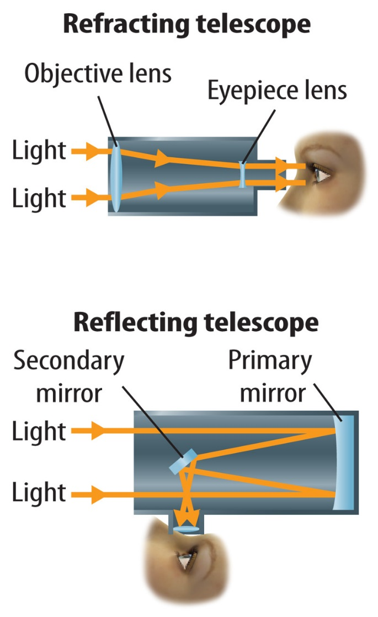 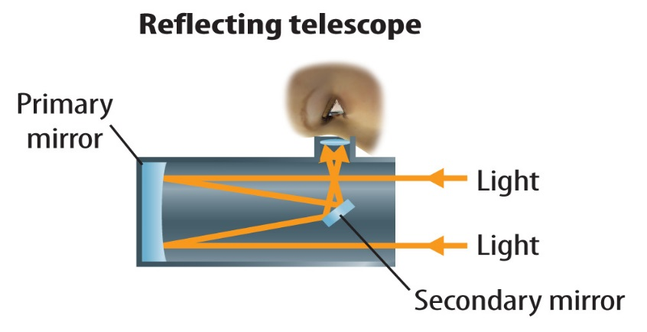

3. What was the first planet studied using a space probe?

4. Which of the following show signs of the possibility of water? Mars, Europa (one of Jupiter’s moons), Jupiter, or Mars and Europa?

5. The three things required for life to exist as far as we know are _______________, ____________________, and _________________ ____________________ (we discussed these as a Do Now in class).

6. A star’s ____________________ is determined by studying the amount of each wavelength it emits.

7. Differentiate between a crewed space shuttle, space probe, rocket and crewed spacecraft. In other words, when is each one used?

8. Which of the following helps to power missions to the outer planets: wind, gravity from planets as they are passed, solar power, or anti-matter? ________________________________

9. In what year was the moon last visited? ____________________

10. What is the role of the *Lunar Reconnaissance Orbiter?*

11. Differentiate between a crewed and unscrewed space mission.

12. Stars emit _____________________________ energy.

13. Which location(s) in the U.S. are rockets launched from by NASA? ___________________

_____________________________________________________________________________

14. ______________________ was the first artificial satellite to orbit Earth.

15. Where are most radio telescopes found?

16. Which type(s) of electromagnetic waves reach the Earth’s surface?

17. The first optical space telescope was ___________________________________________.

18. Study this diagram of the electromagnetic spectrum.

