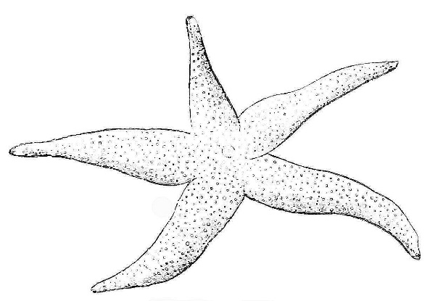
Chapter 11, Lesson 2, page 438
Asexual Reproduction
What is asexual reproduction? Asexual production is when a single parent produces offspring without ________________________ and without __________________________. Mitosis is a kind of asexual reproduction because only one cell is required for it. So, even though you are a product of _______________________________________, you have grown over time because your cells reproduced _______________________________________. Whenever an organism or cell reproduced asexually, the offspring are ________________________________ of the parent (yes, parent is singular!).
Types of Asexual Reproduction
- Fission
  - Bacteria reproduce through a process called __________________ fission. Bacteria only have one, circular ____________________________. Some bacteria can divide every half hour. How many hours would it take for a single cell to divide into at least 1,000 cells?
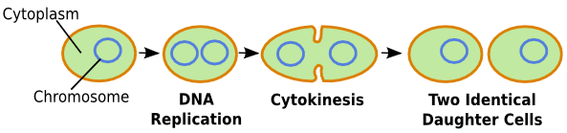
- Mitotic Cell Division
  - ______________________________ have their DNA in a nucleus. _______________________ is the division of the nucleus before the rest of the cell divides in _____________________________. Some eukaryotes only reproduce asexually with mitosis, while others can reproduce both sexually and asexually.
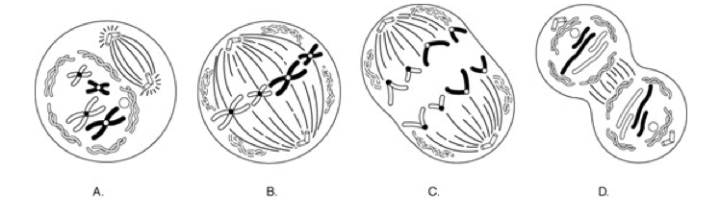
- Budding
  - Budding is when a new organism grows by _______________________, and it is still attached to its parent. At some point in the future it may or may not break away and live independently.

- Animal Regeneration
  - Some organisms don’t die when you cut them in half or break off their body parts. Instead, a whole new organism _______________________________! An old story says that mussel fishermen used to try to kill sea stars by chopping off their arms and throwing them back in the ocean…
- Vegetative Reproduction
  - Some plants have __________________________, which are like long horizontal stems. When they touch the ground a new plant can start growing.
- Cloning
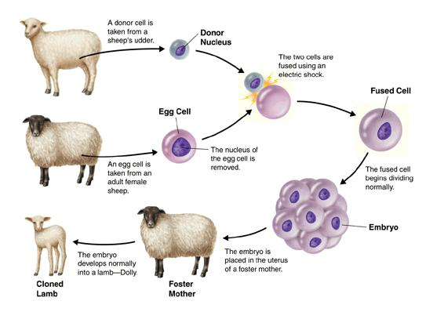
  - Cloning is a new type of asexual reproduction invented by humans. In cloning, an unfertilized __________________ is removed from an animal. The __________________ is removed too, which contained the animal’s _________________. Finally, a new nucleus is inserted into the ovum, and the cell will begin to divide and grow into a new animal. This new animal is a clone of the animal that donated the nucleus.
Advantages and Disadvantages
The advantages and disadvantages of asexual reproduction mirror sexual reproduction. Usually, what counts as an advantage for one is a disadvantage of the other.

