Chapter 11—Reproduction of Organisms
Vocab
- sexual reproduction
- egg
- sperm
- fertilization
- zygote
- diploid
- homologous chromosomes
- haploid
- meiosis
Lesson 1: Sexual Reproduction and Meiosis, page 426
Every human being is the result of ________________________ between a mother and a father. Sexual reproduction is what made you a unique individual. Every human has ______ chromosomes, which are wound up packages of DNA and protein. An ovum in your mother’s ovary contained _____ chromosomes, and a sperm cell from your father’s testis contained _____ chromosomes. These reproductive cells are called ____________. We also call them _________________ because they have half the normal number of chromosomes.
When the ovum and sperm fused together into a single cell, the chromosomes were in pairs, for a total of _____ chromosomes. A cell with chromosomes in pairs is _______________. Biologists organize chromosomes into a ____________________, which puts all the chromosomes in order, from largest to smallest:
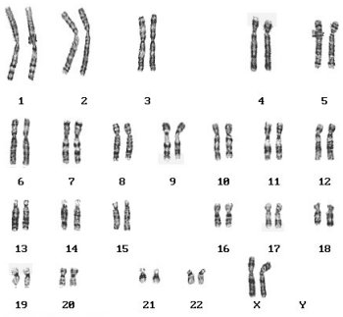
In 6th grade you learned about mitosis, where cells make exact copies of themselves. Mitosis is how you have grown larger during childhood and adolescence, and it is also how your body heals itself when you are injured. Mitosis is NOT how gametes are formed. A sperm is not an exact copy of the father’s cells (after all, it has only half the number of normal chromosomes).
The production of games, ova and sperm, is called ______________. Unlike mitosis, the new cells formed in ______________ are unique; they are not copies of the parent cell; they do not end up with the same DNA. In mitosis, it is sister chromatid that separate in metaphase. It meiosis, ________________________________________ are pulled apart during metaphase I. Homologous chromosomes are the pairs of chromosomes you got from your mother and father. For example, in the karyotype above, there are 23 pairs of homologous chromosomes. Is the individual in the karyotype male or female?
