Lesson 1
1. What are the three principles of the cell theory?  1.  2.  3. | 1. All living things are made of one or more cells  2. cells are the smallest unit of life  3. all new cells come from preexisting cells
2. What scientist belongs in the empty box?  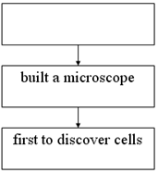 | Robert Hooke
3. What is the name of the scientist who:  a. looked at animal cells  b. looked at plant cells | a. Matthias Schleiden  b. Theodor Schwann
4. Where are nucleic acids found?  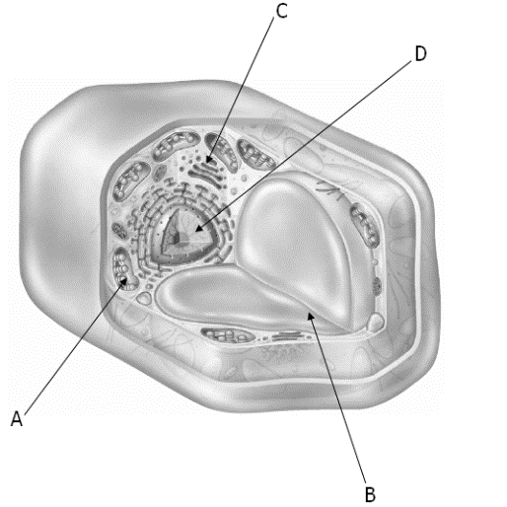 | B- in the nucleus
5. _____________ make up the macromolecule carbohydrate. | sugar
Lesson 2
6. Explain the function of the cell membrane. | Offers protection from the outside environment
7. Which organelle is necessary for photosynthesis to occur? | Chloroplasts
8. Describe the main difference between a prokaryotic cell and a eukaryotic cell. | Eukaryotic cells have its genetics surrounded by a membrane.
9. What is the difference between the rough endoplasmic reticulum and smooth endoplasmic reticulum? | Rough ER– has ribosomes covering organelle  Smooth ER- does not have ribosomes
10. Plant cells that are long and hollow will transport _____ and water throughout the plant. | food
Lesson 3
11. Describe:  Passive transport-  Active transport- | Passive transport moves substances throughout the cell without using the cell’s energy.  Active transport moves substances using the cell’s energy.
12. Materials enter and leave the cell through openings in its _______  _____________. | Cell membrane
13. Describe osmosis. | The passive transport of water through a cell’s membrane
14. What is being shown in each diagram:  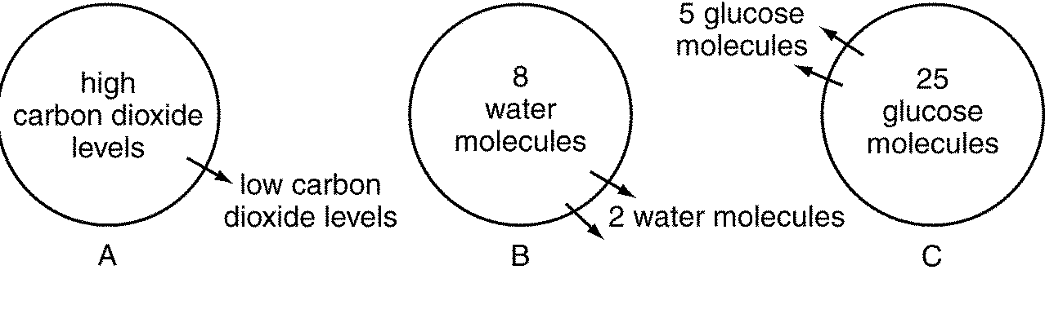  active transport, diffusion, osmosis, equilibrium, exocytosis  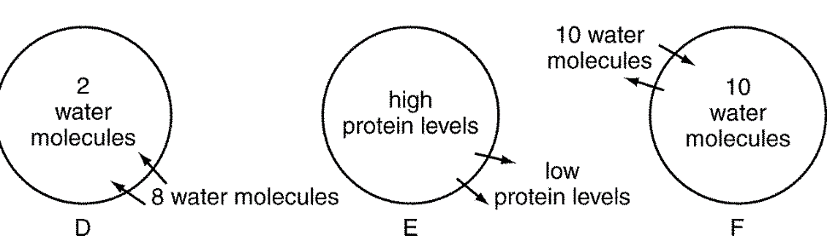 | A. diffusion  B. osmosis  C. diffusion  D. osmosis  E. exocytosis  F. equilibrium
Lesson 4
15. What substance is released during photosynthesis? | oxygen
16. Which form of energy is necessary in photosynthesis? | light
17. What process is being shown below:  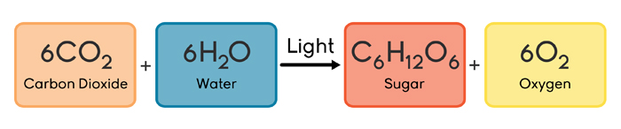 | photosynthesis
Matching
A. cell membrane C. cytoplasm E. golgi bodies G. nucleus  B. vacuoles D. cell wall F. mitochondria H. organelles  ____ 1. Organelles that store food, water, and waste material  ____ 2. Protective layer around all cells  ____ 3. Where the energy in food is stored until it is released  ____ 4. Protects the cells of plants  ____ 5. Flattened membranes that package proteins  ____ 6. Gelatinlike material inside cell membrane  ____ 7. Structures within the cytoplasm of eukaryotic cells  ____ 8. Directs all the activities of the cell | 1. B  2. A  3. F  4. D  5. E  6. C  7. H  8. G

