Name: _____________ Period: ______ Chapter 1 Test Study Guide Test date: Friday 10/13/17
- What are the names of the major earth Systems?
- What are the 5 layers of the atmosphere?

- What happens to the atmosphere as you move towards space?
- Label the gasses that make up the atmosphere in the diagram:
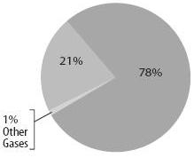
- Where is the ozone layer found?

- Where is groundwater stored?

- What is included in the:
- Geosphere -Biosphere
- Hydrosphere -Cryosphere
- Atmosphere
- What are the characteristics of a mineral?

- Label the layers.
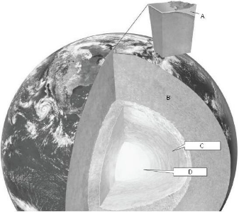
What layer is completely liquid?
- Where is the beginning of the water cycle?

- Water is released from plants through leaves through which process?
- What causes wind?
- What is humidity?
- Why is the leeward side of a mountain dry?

- Compare and contrast Magma and Lava

