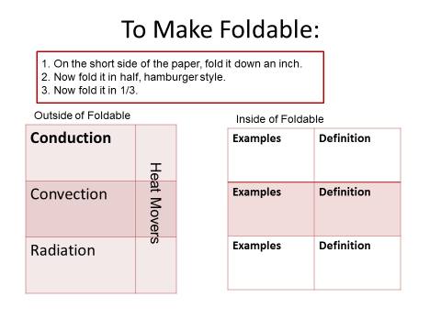
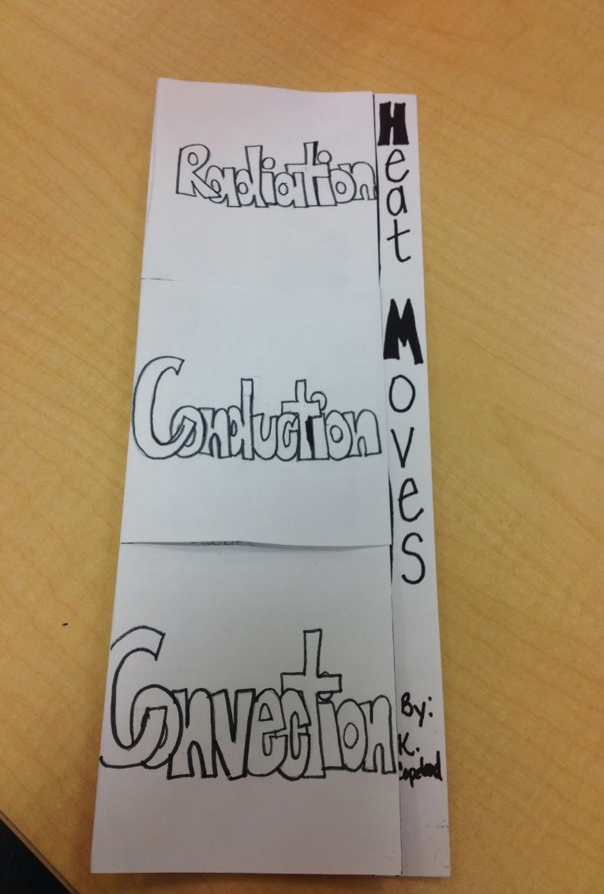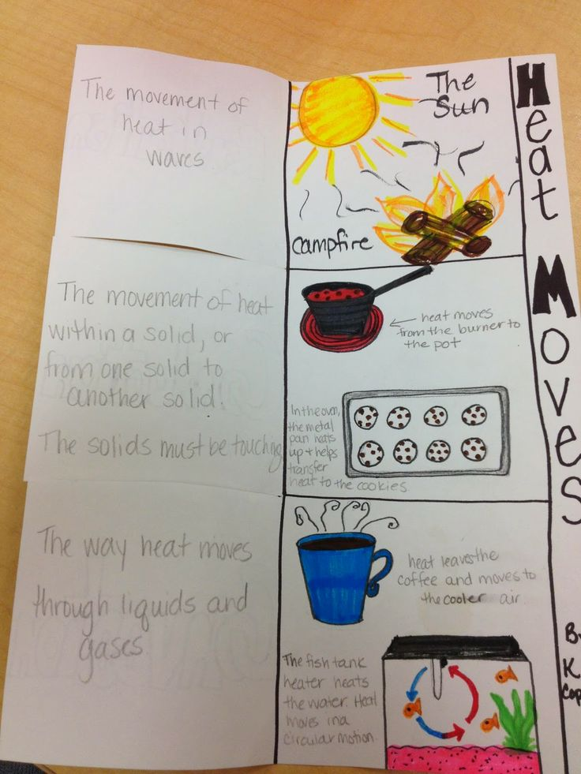

Answer these essential questions on the back of your foldable, in a complete sentence: 1. What is heat? and 2. What is thermal energy?

