Lesson 1
1. A cell spends most of its lifetime in _______________________.
2. the cell cycle consists of:
- G___________
- D__________________
- D_____________________
3. What are the two main phases of the cell cycle?

4. Describe what occurs during the cell’s interphase, and mitotic phase.

5. Name and describe each stage of the interphase.
1.

2.

3.
6. Draw a picture of sister chromatids being held together by a _______________.

7. Name and describe the 2 stages of the mitotic phase. (pictures OK)
1.

2.

8. If a cell has 18 duplicated chromosomes, how many chromatids does it have? (Draw a picture to help)

9. Choose the correct answer:
A(n) animal/plant cell divide by the cell membrane pinching together until the two cells split apart.
10. Describe how a plant cell divides.

Lesson 2
11. Similar cells working together are called _______________.
12. List the 4 types of tissues found in animals, and their function.
1.
2.
3.
4.
12. Photosynthesis takes place in the _______________ tissue of a plant.
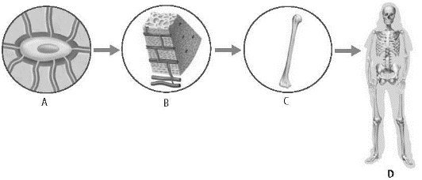
13. Label the diagrams.
Matching
A. Prophase C. Anaphase
B. Metaphase D. Telophase

___ 1. Sister chromatids separate
___ 2. Spindle fibers begin to form
___ 3. Chromosomes line up single file at the middle of the cell
___ 4. Two identical nuclei form

