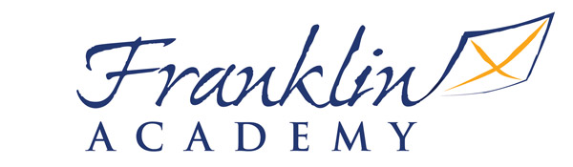

January 6, 2016

Dear Franklin Academy Parents,

Your child has been selected to attend the Academic Olympics Tutorial Program. The selection process included a review of your child’s reading, writing, math diagnostics and/or Discovery Education assessment scores. The Academic Olympics will be held on Saturdays, from 8:30 am to 11:30am, beginning January 23, 2016. The emphasis of the program will be on reading, writing, math and science enrichment as well as remediation opportunities. During this time, highly qualified teachers will work with our students on identified benchmarks within each core content area that will strengthen their academic skills and success. It is very important that your son or daughter regularly attend the program. Your child’s teacher may offer extra credit in the subject for which they are receiving tutorial services.

Please complete the bottom section of this letter and return to your child’s homeroom teacher. If you have any questions or concerns, please do not hesitate to call me at 561-767-7300.

Respectfully,

Christopher Glinton, Ed.S.
Principal

My son/daughter name: ________________________________________

Teacher:______________________________ Grade:________________

________Yes, my child will attend

________ No, My child will not attend

_______________________________________ _____________________
Parent/Guardian Signature Date

