Group Member Names: _____________________ Period: ________ Date: __________
“Building Bridges” – S.T.E.M activity

Essential Questions: 1. How do engineers decide on what type of bridge to build? 2. Why are engineers constantly checking the infrastructure of bridges? 3. Why do you think some bridges incorporate triangular, square, and/or circular shapes into their design?

Hypothesis: Explain using the “If, then, because format” the type of bridge you believe will be able to hold a given weight over a specified amount of time. “If I build a bridge made mostly out of ______ (select your materials), then the bridge will successfully hold a weight of _____ lbs. for ___ minutes, because…”

Materials: Notebook or Graph paper (to design your bridge), popsicle/craft sticks (100 sticks per group), tape, Elmer’s Glue-All or Elmer’s Wood glue, string or yarn, scissors, 15 oz. can of vegetables or and a 1 lb. bag of rice or sand.
Research: Collectively as a group, look up the following bridges, mainly their strengths and weaknesses, and decide which one is the best design for this project.
• Beam bridge • Suspension bridge • Arch bridge • Cantilever bridge
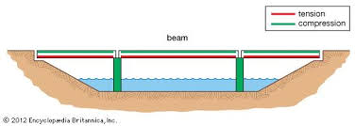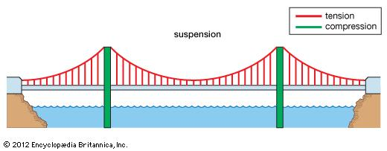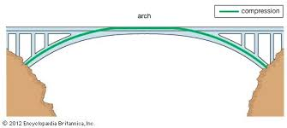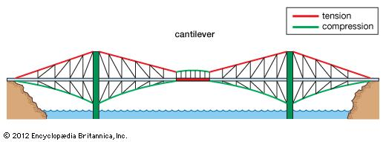
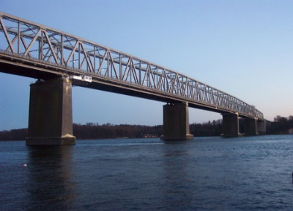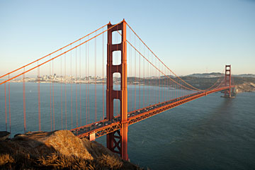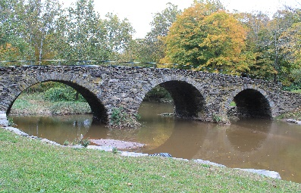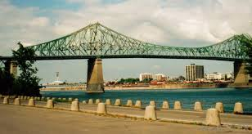

Procedure:
1. Determine/research/brainstorm as a group which bridge type will allow you to hold the designated weight for the required amount of time, which is _________ minutes.
2. Measure the maximum area that your bridge can be by calculating the length (_____cm) and width (_____cm) of ¼ your student desk. Max Bridge area = _____cm²
3. “Design” your “bridge” using one of the four above bridge designs and any combination of the materials provided to you. (DO NOT BREAK OR TEAR TOOTHPICKS OR POPSICLE STICKS). It is okay if your bridge slightly goes over the designated area of your desks. Be creative and remember that design determines the amount of weight that can be supported.
- As you are working, test what you are doing by placing smaller objects of lesser weight to sit on top of your bridge. Note areas that need to be reinforced or redesigned. If your bridge falls apart without any weight on it, rethink your design.
4. Use tape or glue to secure your bridge. Your bridge must be removable and cannot attach directly to the desk for support.
5. If you choose to use glue for all or some of your bridge, remember to allow it to dry before placing any weight on it. Your bridge must be able to hold he designated weight for a minimum of five (5) minutes.
Data:
6. **Make sure you label all the parts with the materials you think you will use.
1st Sketch | 2nd Sketch
3rd Sketch | Final Sketch
7. Notes below: (These notes can be what problems/solutions to create your bridge, how you solve them, what materials worked or didn’t worked, what you had to change/adjust while making your bridge…).
_____________________________________________________________
_____________________________________________________________
_____________________________________________________________
_____________________________________________________________
Conclusion:

QUESTIONS –

1. Test your Bridge:
• Is your bridge at least 12” long? Yes _____ No _____
• Does your bridge support/hold at least ~1 lb.? Yes _____ No _____
• Does your bridge hold this weight for at least five minutes? Yes _____ No _____
• Is there a way to get onto and off your bridge? Yes _____ No _____

2. Evaluate your Bridge:
• What would you have done differently? _________________________________________________________________________________________________________________________________________________________________________________________________________________________________
• What could you add to it to make it better? ______________________________________________________________________________________________________________________________________________________
___________________________________________________________________________
• What was the easiest part to build/what was the most difficult? ______________________________________________________________________________________________________________________________________________________
___________________________________________________________________________
• How does this bridge relate to “real--‐life”? How would it be used? Where would it be located?
______________________________________________________________________________________________________________________________________________________
___________________________________________________________________________
• Were there any materials that you did not used and why?
______________________________________________________________________________________________________________________________________________________
___________________________________________________________________________
• What materials were the most useful? Least useful?
______________________________________________________________________________________________________________________________________________________
___________________________________________________________________________
• How does your structure relate to our everyday lives?
______________________________________________________________________________________________________________________________________________________
___________________________________________________________________________

BRIDGE PAGE
Draw and label your bridge here

Bridge Name ____________________________
Area ___________ cm²
How long did your bridge hold the weight? _____ < 5 min. _____ = 5 min. ______ > 5 min. How much time exactly did your bridge hold the weight? ______ seconds / minutes

