Name: _______________________________ Date: _______________ Period: ______
8th grade - Chapter 3 Study guide: Stars and Galaxies

1. Terms to know: apparent and absolute magnitude, astronomical unit (AU), luminosity, light-year, planetary nebulae, parallax, sunspots, solar flares, solar winds, coronas, black holes, prominences, and Milky Way galaxy (what is it and where are we located).

2. Study this diagram and be able to label the layers of a star (photosphere, convection zone, radiative zone, and chromosphere).
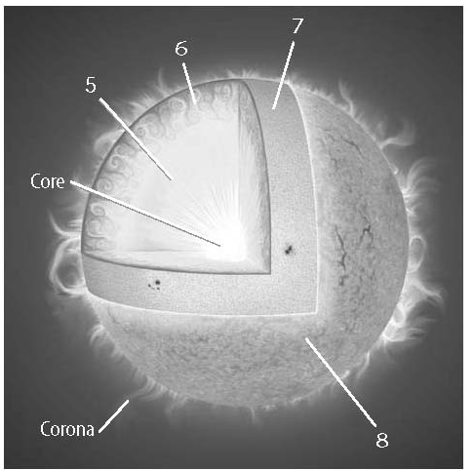
A –
B –
C –
D –

D
C
B
A

3. Difference between constellations and galaxies

4. Differences between an elliptical, irregular and spiral galaxies

5. The Doppler shift (also consider red and blue shift). What is it? What does it tell us?

6. How is the temperature of a star related to its color?

7. What does a star’s luminosity describe?

8. Where do stars form?

9. Describe what the Big Bang theory states.

10. What are the stages in the life cycle of a massive star (hint: there are four)?

