Chapter 5 Study Guide Test: 1/15/16
Lesson 1
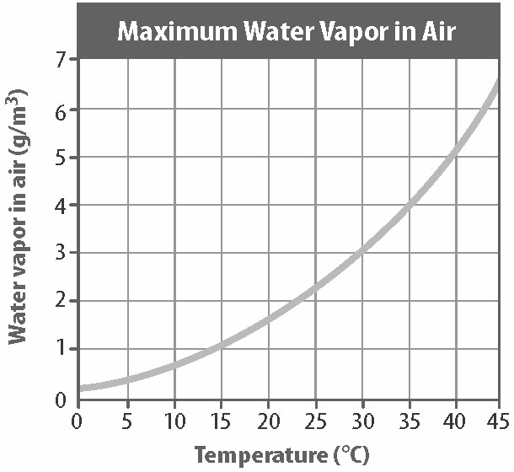
- What is the water vapor in the air at 25 degrees? At 35 degrees?
- 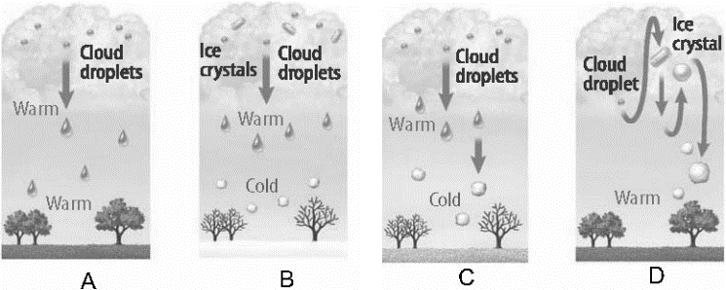
Match the following: rain, snow, sleet hail
- ________ humidity is the measure of the amount of water vapor that air is holding.
- What is it called when the air is saturated and condensation is formed?
Lesson 2
- Draw a high pressure system, and a low pressure system

- Tornadoes are rated on a __________ __________ to report damage. What is the most severe rating?
- Explain the difference between a severe weather WATCH and WARNING.

- Although typically wind speeds in tornadoes are faster than wind speeds in hurricanes, hurricanes inflict more overall damage. Why do you think that is?
- Describe the weather at areas of low pressure and high pressure.
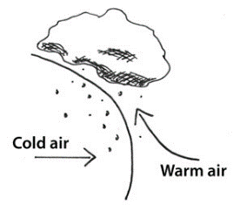
- What type of front is being shown? What is the boundary between the two called?

Lesson 3

- True or false: weather maps have symbols that show the humidity, dew point, and type of precipitation?
- Weather maps have lines drawn connecting points of equal pressure. What are those lines called?
- Weather maps have lines drawn to connect points of equal temperature. What are those lines called?
- Draw the symbol for:
Warm front:
Cold front:
Occluded front:
Stationary front:
- Describe what a radiosonde is.
Matching
A. thermometer E. Maritime Polar
B. barometer F. Maritime Tropical
C. anemometer G. Continental Tropical
D. human observers H. Continental Polar

____ temperature ____ warm and humid
____ wind speed ____ cool and humid
____ air pressure ____ warm and dry
____ cloud amounts and visibility ____cold and dry

