Name: _____________ Period: ______ Chapter 1 Test Study Guide Chapter 1 Test is scheduled for: Tuesday, 10/20/15
- What are the names of the major earth Systems? | Geosphere, Hydrosphere, Biosphere, Atmosphere
- What are the 5 layers of the atmosphere?  - What happens to the atmosphere as you move towards space? | Troposphere (lowest), stratosphere, mesosphere, thermosphere, exosphere (highest).  The temperature varies with each layer, and the higher you go, the colder it gets.
- Label the gasses that make up the atmosphere in the diagram:
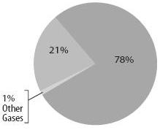
- Where is the ozone layer found? | stratosphere
- Where is groundwater stored? | In cracks and pores beneath the Earth’s surface
- What is included in the:  - Geosphere -Biosphere  - Hydrosphere -Cryosphere  - Atmosphere | G- rocks, mountains C-79% of freshwater in glaciers,  H- water snow and icebergs  A-Nitrogen, Oxygen, other trace gases  B- Living
- What are the characteristics of a mineral? | Naturally occurring, inorganic, solid, crystal structures, definite chemical composition
- Label the layers.  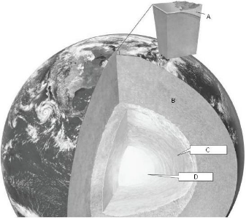  What layer is completely liquid? | The outer core is liquid
- Where is the beginning of the water cycle? | There is no true beginning. The water cycle is a continuous process in which water travels throughout the Earth and atmosphere.
- Water is released from plants through leaves through which process? | Transpiration
- What causes wind? | Difference in air pressure
- What is humidity? | the amount of water vapor in a given volume of air
- Why is the leeward side of a mountain dry? | As the air on the windward side rises and cools, the water vapor condenses and precipitation occurs, leaving little precipitation for the leeward side
- Compare and contrast Magma and Lava | Lava: melted rock on Earth’s surface  Magma: Melted rock under Earth’s surface  Both: Melted Rock

